Istanbul Technical University- Fall 2010

BLG381E, Advanced Data Structures

Report for Homework 1
Name: Aykut
LastName: Akın
Student ID: 040080177
Email: akinay@itu.edu.tr
Date:
Instructor: Zehra Çataltepe

Q1) If we compare the numbers;

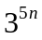 and 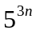 => >
-Because power of 3⁵ = 243 and 5³ = 125. So becomes larger than .
and 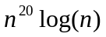 => >
-Because n^{b} = o(a^{n}). So that can not become larger as .
and 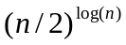 => >
-Because contains ‘n’ both power and base. It is larger than any function.

So; > > >

Q2)
- Master method can not be applied to this recurrence. Because we only use it for this kind of recurrences: T(n)=aT(n/b)+f(n).

- T(n) = T(n-1) + 1/n Recurrence Tree
T(n-1) = T(n-2) + 1/(n-1) 1/n
T(n-2) = T(n-3) + 1/(n-2)
T(n-3) = T(n-4) + 1/(n-3) 1/(n-1)
: : :
: : : 1/(n-2)
: : :
T(3) = T(2) + 1/3 :
T(2) = T(1) + 1/2 :
_____________________ :
_{n} 1/3
T(n) = T(1) + (∑ 1/k ) – 1
^{k=1} 1/2
= T(1) + O(ln n) – 1
= O(ln n) T(1)

Description of how your program should be compiled and run:
I use Microsoft Visual C++ 2010 Express to develop the program. Program can be compile and run on it on Linux/Unix using g++.

You should give a command like that for use the BuildMaxHeap function.
heapsort –i initdata1.txt –t b
You should give a command like that for use the Heapsort function.
heapsort –i initdata1.txt –t s

If you give build heap command, program is going to run and write the sorted output to the “output/filename_b”. If you give sort command, program is going to run and write the sorted output to the “output/filename_s”. After that “output/time.txt” is going to be created and filled with running time of readData, writeData and heapsort functions.

ASSIGNMENT d)
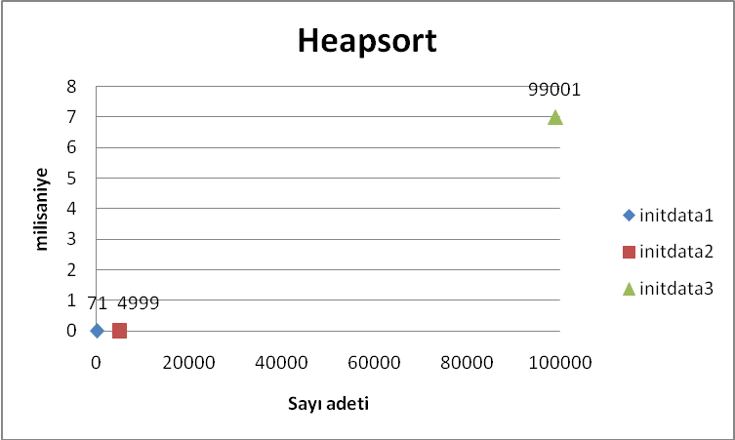

Q3) How much time (in minutes) did you spend:

Procrastinating | 0 minute
Understanding the homework | 30 minutes
Solving questions 1 and 2 | 10 minutes
Understanding the pseudocode | 0 minute
Writing the code | 90 minutes
Testing the code | 20 minutes
Getting the outputs and preparing the report | 40 minutes

